Question answering system for automated customer relationship management

Problem Statement

The problem of automated question answering system is to automatically answer the questions without waiting for some personnel to handle the query. Question answering (QA) is a well-researched problem in NLP. In spite of being one of the oldest research areas, QA has application in a wide variety of tasks. Recently, QA has also been used to develop dialog systems and chatbots designed to simulate human conversation However, with recent developments in deep learning, neural network models have shown promise for QA. Although these systems generally involve a smaller learning pipeline, they require a significant amount of training. GRU and LSTM units allow recurrent neural networks (RNNs) to handle the longer texts required for QA. Further improvements – such as attention mechanisms and memory networks – allow the network to focus on the most relevant facts. Such networks provide the current state-of-the-art performance for deep-learning-based QA. The challenges which are faced while designing the Automated QA CRM is how to deal with individual human ,how to understand his/her sentences if they are misspelled/ shortforms , how much time it needs to understand a human, how well it map with the intent of human.

Background Work

Despite of the challenges given in the problem statement self driving car is still an active area of research. Numerous approaches have been proposed over the years. In spite of being one of the oldest research areas, QA has application in a wide variety of tasks, such as information retrieval and entity extraction. Recently, QA has also been used to develop dialog systems and chatbots designed to simulate human conversation. Traditionally, most of the research in this domain used a pipeline of conventional linguistically-based NLP techniques, such as parsing, part-of-speech tagging and co-reference resolution. Many of the state-of-the-art QA systems – for example, IBM Watson use these methods.

Prior to this work there has been application of various concepts like attention mechanisms to the CNN. There is another important concept of memory network, dynamic memory networks. Other researcher applies end-to-end memory networks to achieve state-of-the-art results with weak supervision. Other researcher also focused on a template-based approach to SPARQL query generation and handle constructs that are not captured using semantic triple representation
Methodology
- Data Collection and Dataset Preparation: This will involve collection of data from various sources.In this research the data is collected as 2 dataset of MCTest.
- Training: The data is tested and trained using a baseline model built with keras and tensorflow –a GRU model
- Deployment and analysis on real life scenario: The model developed is deployed for further analysis where both positive and negative cases will be used for further improvement in methodology.

Automated QA Model
Model Development
Input Image Chatbot
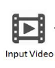

Training & Testing

QA Dataset

Figure 1: Architecture of Automated QA CRM System

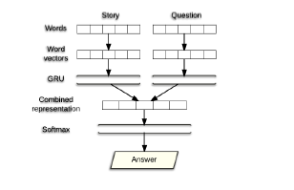
Figure 2:GRU Baseline used as model [Eylon Stroh et al. Question Answering using Deep learning]

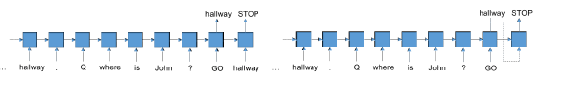
Figure 3: Seq-to-Seq Baseline used as model [Eylon Stroh et al. Question Answering using Deep learning]
Experimental Design
Dataset: Automated QA dataset is made by gathering two MCTest dataset.

Evaluation Measures: Measures such as accuracy and time to respond will be used.
Software and Hardware Requirements: Python programming language, Keras, tensorflow and NVIDIA GTX 1070 GPU 8 GB.

